Cloud Wind Puppet  Thank you to Nichole for sharing this craft idea with us!  Materials:  - Paper  - scissors  - glue or stapler  - White ribbon  - scrap paper  - OPTIONAL: markers or pencil crayons  Instructions:  - Fold a white piece of paper in half and cut out a cloud shape.  (Or you can print the cloud template below, fold it in half and cut it out)  - Staple 3 sides of the cloud together and leave the 4th side open like a pocket.  (I stapled, because it was faster. Glue looks a lot better and doesn't have sharp edges!)  - Hole punch a few holes in one end and tie some white ribbon into the holes to hang out like streamers.  - Once the ribbons were tied and knotted, we used shredded paper to stuff the cloud.  (You can used the stuff in your shredder garbage can, you can use scraps from the stuff you cut, you can use newspaper, or you can use any discarded paper to recycle it. I used finished school work that we didn't need any more, and I cut it into strips to crunch.)  - Once the cloud is stuffed, staple or glue the last side together. | 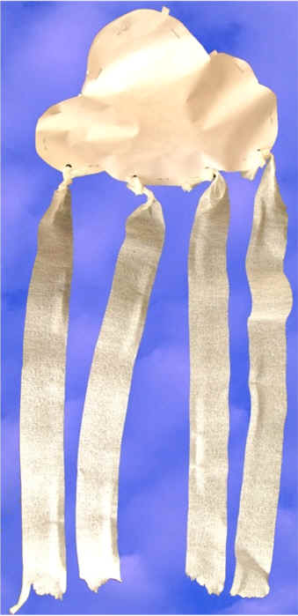
You now have a wind puppet!
We drew faces on ours. The girls helped them and danced around the room whistling and talking about what kinds of things they moved with the wind (leaves, grass, hair, etc.)

(Craft taken from DLTK-Kids.com)

